Movie Recommendation System Report
Introduction
This report aims to summarize a movie recommendation project which was analyzed from the MovieLens 10 M data set to determine how users rate movies and evaluate predictive accuracy using the root mean squared error (RMSE).
The workflow loads and cleans the ratings and movie metadata, creates a training set and a final hold-out test set, tunes a regularization parameter on an internal validation split, estimates a regularized movie-and-user bias model, and evaluates the fitted model on unused data. Using the supplied analysis, the selected regularization strength is lambda = 5 and the final model achieves an RMSE of 0.8648177.
Figure 1: Steps used in the project

Methods/analysis
The proccess is started by loading tidyverse and caret followed by downloading the data set( MovieLens 10M) from from GroupLens.org.
The code begins by loading tidyverse and caret, then downloading the MovieLens 10M files from GroupLens.org. The ratings.dat file is parsed into four fields (userId, movieId, rating, timestamp), while movies.dat provides movie titles and genres. Both tables are cleaned so that identifiers and ratings are stored using the appropriate numeric types before being merged into a single analytic table.
A 10% final hold-out set is sampled from the full data. To ensure every observation in the hold-out set can be scored, the code keeps only user IDs and movie IDs that also appear in the training data; any excluded rows are returned to the training set.
The model itself is a regularized additive which estimates the global mean rating, a movie-specific effect, and a user-specific effect. Regularization shrinks large effects toward zero when a user or movie has relatively few observations. The tuning parameter lambda is selected by trying values from 0 to 10 in increments of 0.25 and choosing the value that minimizes validation RMSE.
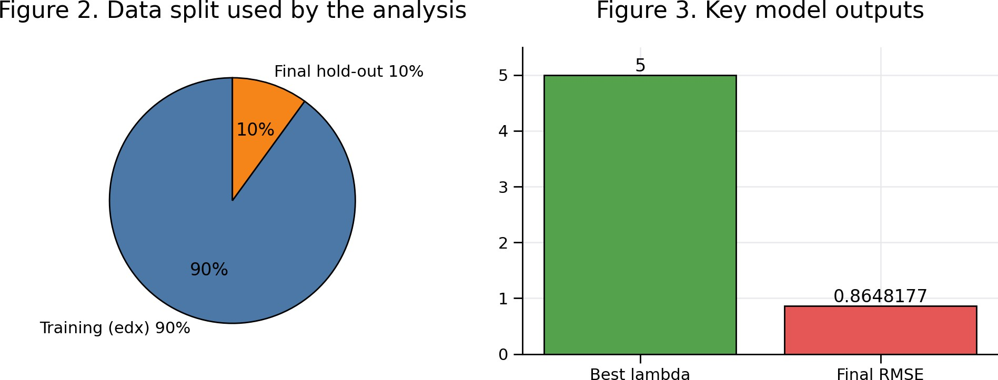

Results
The internal validation procedure selected lambda = 5 as the best regularization value. The final model was then re-estimated on the full training set (edx) and used to predict ratings for the unused final hold-out test set. The resulting final RMSE is 0.8648177 which is < 0.86490.
Metric | Value
Model class | Regularized movie + user effects
Validation tuning grid | lambda = 0 to 10 by 0.25
Selected lambda | 5
Final RMSE | 0.8648177

Conclusion, Limitations, and Future Work
In summary, the project successfully builds a reproducible movie recommendation workflow from the MovieLens 10M dataset and shows that a regularized bias model can achieve strong predictive accuracy with relatively modest complexity. The chosen lambda of 5 and the final RMSE of 0.8648177 indicate that the model generalizes well to the hold-out set.
The main limitations are that the model uses only additive user and movie effects and does not include richer information such as latent factors, time effects, or the full content information available in genres and titles. Future work could extend the approach by adding genre terms, temporal adjustments, matrix factorization, or ensemble methods, and by evaluating recommendation quality using ranking metrics alongside RMSE.

